A

PROJECT REPORT

ON

FLIGHT MANAGEMENT SYSTEM

Submitted

By

Sakura

符策彬 R8J9400160

姜力 R8J9400159

赵晗 R8J9400145

赖成溪 R8J9400131

HaiNan University





Starting Date:5 May 2019

Ending Date:16 May 2019

PROJECT INDEX

|  |  |  |
| --- | --- | --- |
| S no. | Particulars | Page no. |
| 1 | TEAM DESCRIPTION & OVERVIEW | 4 |
| 2 | CERTIFICATE | 5 |
| 3 | ACKNOWLEDGEMENT | 6 |
| 4 | About the Requirements,  Software Design | 7-9 |
| 5 | Database Design | 10 |
| 6 | Case Diagram | 11 |
| 7 | DFD of Login module | 12 |
| 8 | DFD of Administrator module | 12 |
| 9 | DFD of Customer module | 13 |
| 10 | **Snapshots**  Login module  Personal Center module  Booking module  Modify Information module  New User module  Retrieve Password Module  Retrieve Password Module  Add Flight module  Update Flight module  Delete Flight module  Skip the Login and Book Directly Module | 14-22 |
| 11 | **Source code of**  Connection1.java  Login_interface.java  Personal_Center.java  Booking.java  Result1.java  Successful_Booking.java  Modify_Information.java  Retrieve_Password.java  New_User.java  Administrator.java  Flight_Management.java  New_Flight.java  Update_Flight.java  Delete_Flight.java  Result2.java | 22-75 |

TEAM DESCRIPTION & OVERVIEW

符策彬：Captain, from class B2, is responsible for customer module in this project.

姜力：team number, from class B2, is responsible for administrator module in this project.

赵晗：team number, from class B2, is responsible for customer module and UI.

赖成溪：team number, from class B2, is responsible for writing database.

|  |
| --- |
| **CERTIFICATE**  This is to certify that this report,titled Flight Management System,embodies the original work done by Fucebin,JiangLi,ZhaoHan and LaiChengXi in partial fulfillment of their course requirement at NIIT.    Coordinator: Ashok  de-cai Liu |

**ACKNOWLEDGEMENT**

**T**his project has been written for over a week.Feel in this more than a week, we harvest a lot.The previous knowledge forms a system here, which is no longer so fragmented.Secondly, without the previous high expectations and low skills, I really found that many basic knowledge had the problem of vague concepts in practice, and then forced us to understand it, which achieved the effect of reviewing old knowledge and learning new knowledge accidentally.Because we didn't learn some of the knowledge we used, we looked for solutions on the Internet.This makes us learn more.

**I**n this process, we learned a lot.In this, I also want to thank Ashok and de-cai Liu teacher and those who give us help students, two teachers in our project to do is to accompany in our side, if we encounter problems, they can be said to be on call, their interpretation of the nuanced, easily understood, to help us solve a lot of confusion, also guide us how to program.It can be said that without their help, we can not write such a good project.

Sincerely

Team Name: Sakura

Place: HaiNan University

Date:23 May 2019

**PROJECT REPORT**

**FLIGHT MANAGEMENT**

**SYSTEM**

Every airline has its own booking system, and that's what we want to do.At the same time, due to the limited size, we put the administrator login interface and customer booking together, but also to a certain extent simplifies the operation steps.We call our proposed system as FMS, which is being developed for the management of flight and the booking of customers .

**Software Requirements**

1. JDK 1.8
2. NetBeans 8.2
3. MySql

FMS can achieve the following basic functions.For customers, the FMS provides the functions of booking tickets, modifying personal information and accumulating points.For those newly registered members, the personal information input is judged to be successful, and the information will be recorded in the database.After successful login, you can search the flight information according to the source and destination you input, and then click on the specific requirements input according to the feedback information to book the ticket.If you are the administrator, after logging in, you can query the flight information, and at the same time, you can add, modify and delete the flight information.

**Requirement Analysis**

Before you start a project, the first thing to consider is requirements. Through a proper analysis of the problems of the existing system, the needs to be filled by the new system can be found, which is called demand analysis. Requirements analysis is the most important part to consider before developing any project, as it is important to understand the goals that you want to achieve by developing this project. This analysis identifies the problems faced by users or clients and possible solutions to their problems. We can use some questionnaires to find out what problems our customers are facing. The system will help administrators do all the relevant work, so the analysis section includes the inconvenience and hassle of large amounts of data that require a lot of manual and manual processing, such as：

• Flight data is too large Entering, storing and searching of employing information manually are time consuming and error prone process:

• In flight management, there is a large amount of information, including flight number, date, departure city, arrival city, departure time, arrival time, class, fare, with too large data, manual copying is basically impossible to achieve, in addition to cumbersome, manual error rate is extremely high, the use of software is convenient, So it is necessary to use software to conform to the economy and logic.

Easy for customers to use, Customer booking tickets are usually booked in advance, if you do not use the software to purchase at the airport, will make the purchase of tickets become extremely inconvenient, the use of software to facilitate customers to buy tickets and view information, such as date, fare, departure time and other information.

Easy for administrators to manage, Administrators can be directly managed through software, additions, deletions and changes can be done, greatly improving the efficiency of administrators

**Software Design（软件设计）**

Software design is a solution- “how to approach the creation of a new system”. This important phase is composed of several steps. It provides the understanding and procedural details necessary for implementing the system recommended in the feasibility study.

In software design, there are three distinct types of activities:

* External design
* Architectural design
* Detailed design

**External Design**

External design of software involves conceiving, planning out and specifying the externally observable characteristics of a software product. These characteristics include user displays, report formats, external data sources, functional requirements , performance requirements and high-level process structure for the product.

External design begins during the analysis phase and continues in the design phase.

**Internal Design**

Internal design involves conceiving, planning out and specifying the internal structure and processing details of the software product. The goals of internal design are to specify internal structure and processing details, to record design decision and indicate why certain alternatives and trade-offs were chosen, to elaborate the test plan, and to provide a blueprint for implementation, testing, and maintenance activities.

**Architectural design**

Architectural design concerned with refining the conceptual view of the system, identifying internal processing functions, decomposing high-level functions into sub-functions, and defining internal data streams and data stores, and establishing relationships and interconnections among functions, data streams, and data stores.

The software will be designed according to the various modules required to full fill all the requirements uncovered in our requirements analysis. The whole system can be divided into a number of modules. The following modules can be recognized in our project:

* Login module
* Administrator module
* Customer module

**Database Design**

The whole project is in fact an information management system, which interacts with the database having a number of tables. The tables with their column names and data type are as follows.

|  |  |  |  |  |
| --- | --- | --- | --- | --- |
| User | | | | |
| **Field Name** | **Data Type** | **Size** | **Primary Key** | **Null** |
| User_Name | Varchar2 | 20 | Y |  |
| Password | Varchar2 | 20 |  | N |
| ID_Number | Varchar2 | 25 |  | N |
| Phone_number | Varchar2 | 20 |  | N |
| Full_Name | Vaechar2 | 10 |  | N |
| Point | Varchar2 | 10 |  | N |

|  |  |  |  |  |
| --- | --- | --- | --- | --- |
| Administrator | | | | |
| **Field Name** | **Data Type** | **Size** | **Primary Key** | **Null** |
| ID | Varchar2 | 20 |  |  |
| password | Varchar2 | 20 |  |  |
| name | Varchar2 | 20 |  |  |

|  |  |  |  |  |
| --- | --- | --- | --- | --- |
| Hangban | | | | |
| **Field Name** | **Data Type** | **Size** | **Primary Key** | **Null** |
| FLT_NO | Varchar2 | 20 |  |  |
| place_of_departure | Varchar2 | 20 |  |  |
| data | Varchar2 | 20 |  |  |
| go_off | Varchar2 | 20 |  |  |
| rank | Varchar2 | 20 |  |  |
| price | Varchar2 | 20 |  |  |

**Use Case diagram**

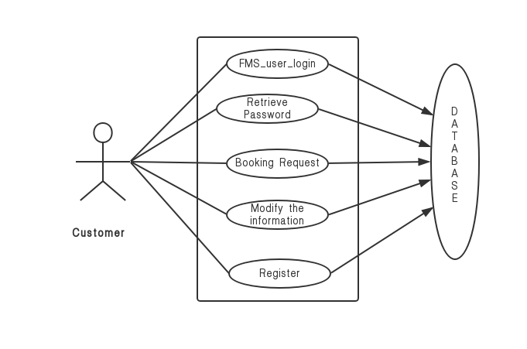

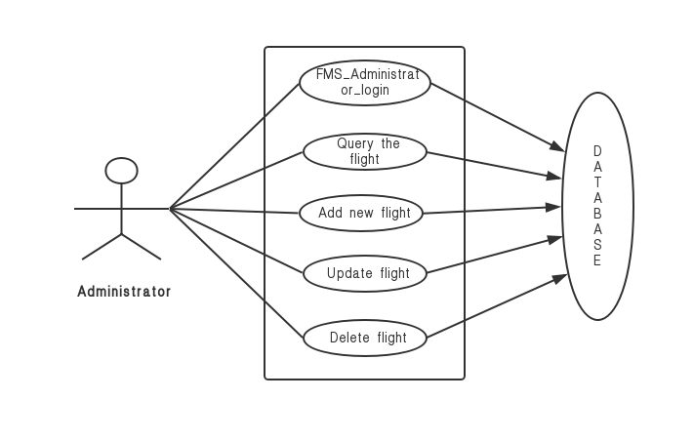

**Data Flow Diagram:-**

**DFD of Login module**

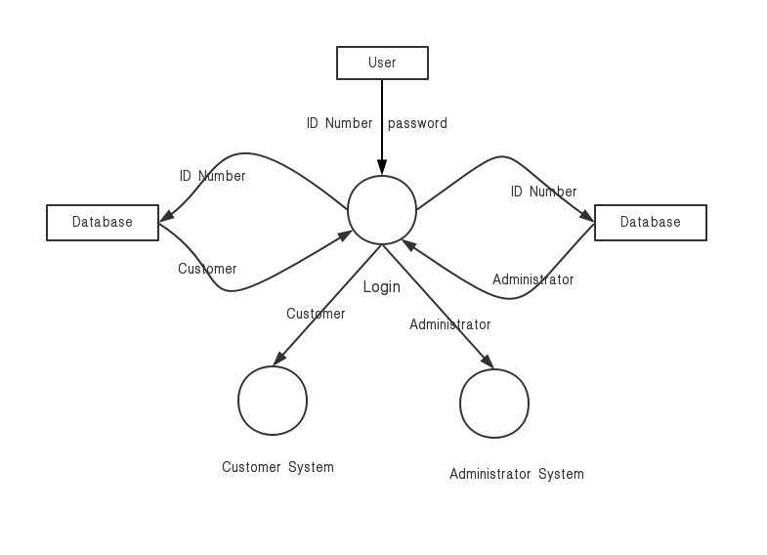

**Administrator module DFD**

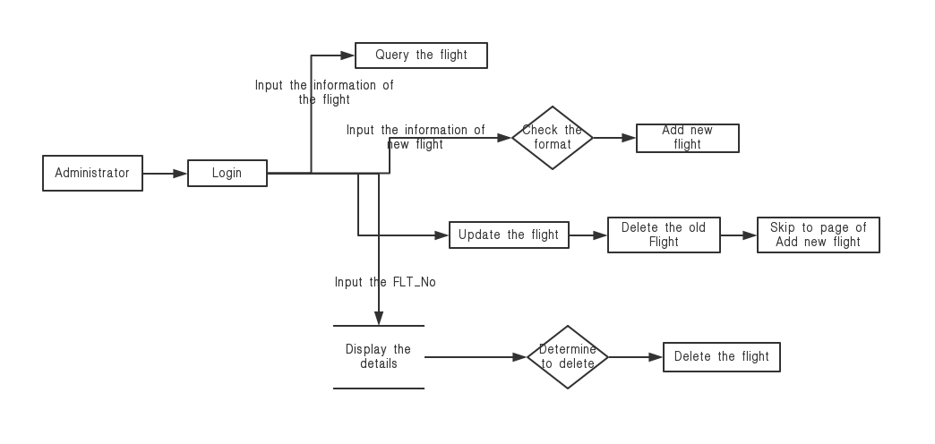

**Customer module DFD**

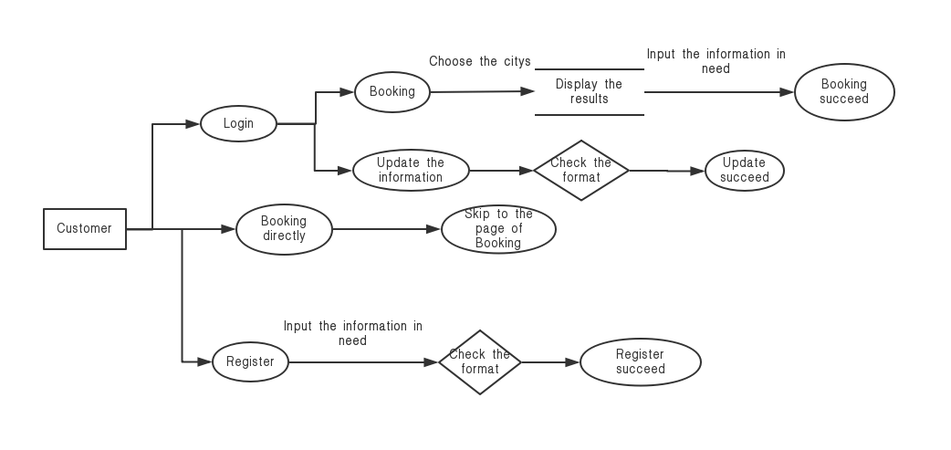

**Login module**

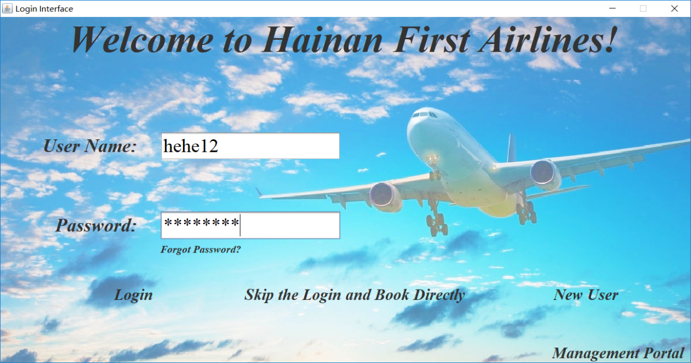

**Personal Center module**

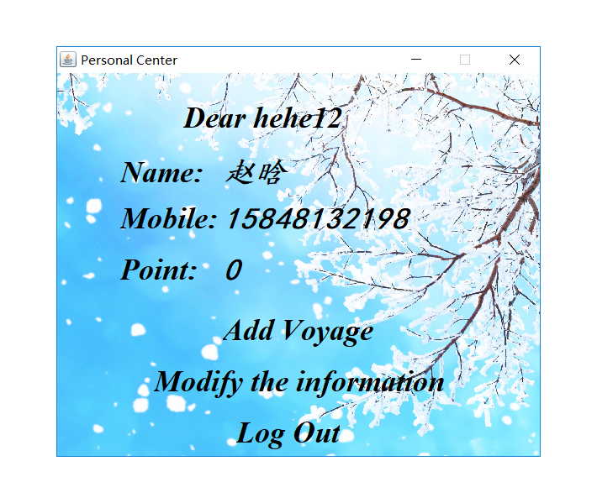

**Booking module**

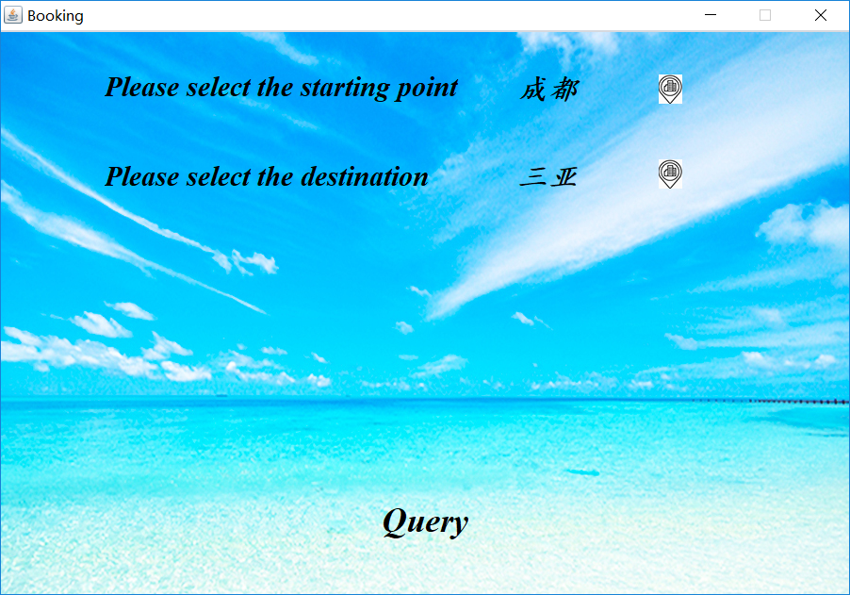

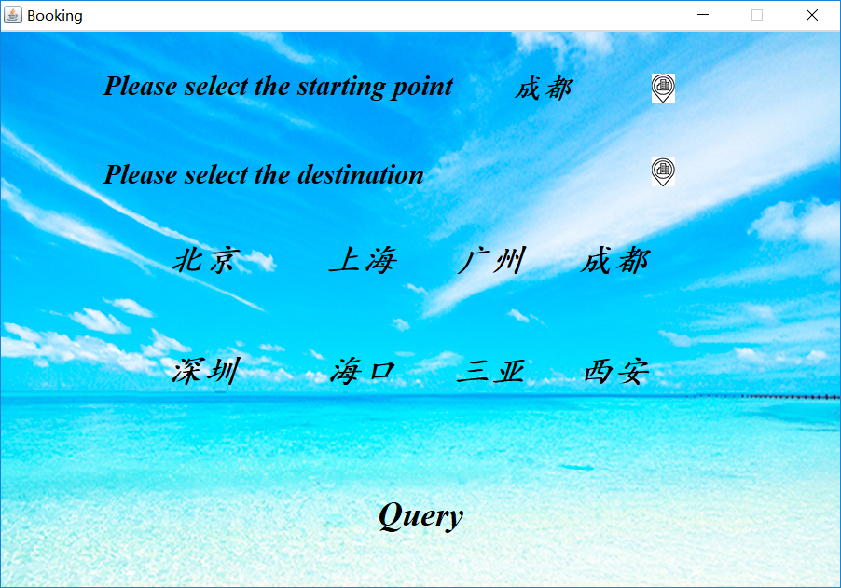

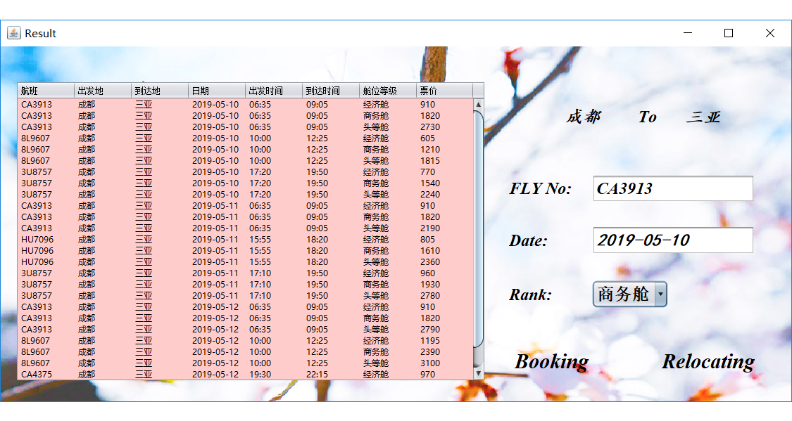

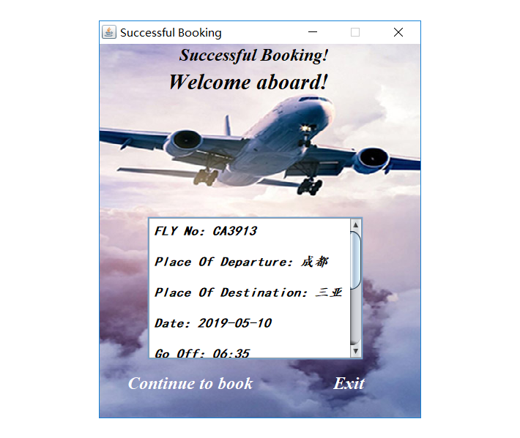

**Modify Information module**

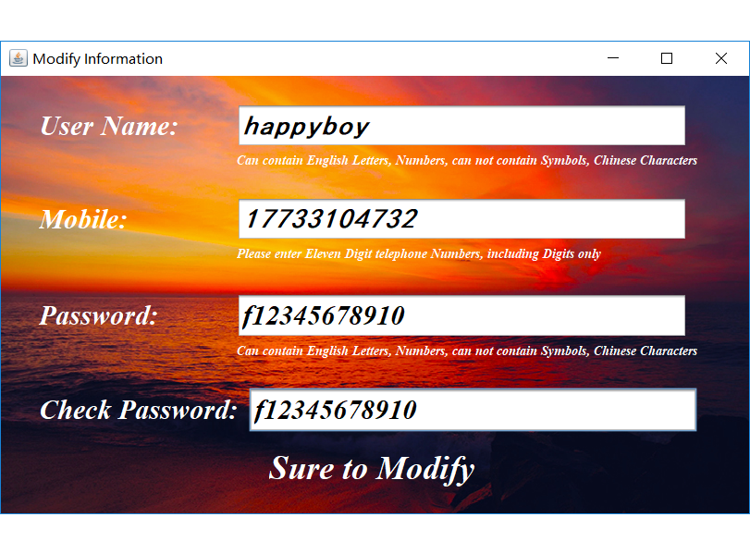

**New User module**

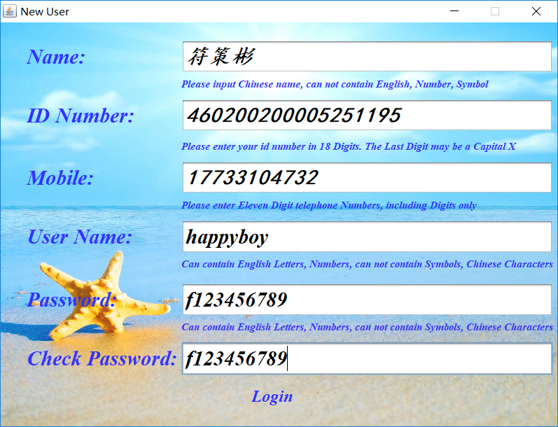

**Retrieve Password Module**

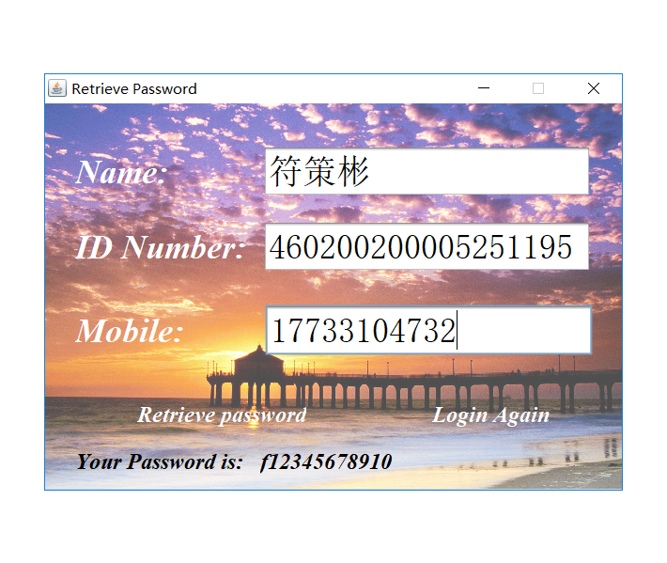

**Administrator module**

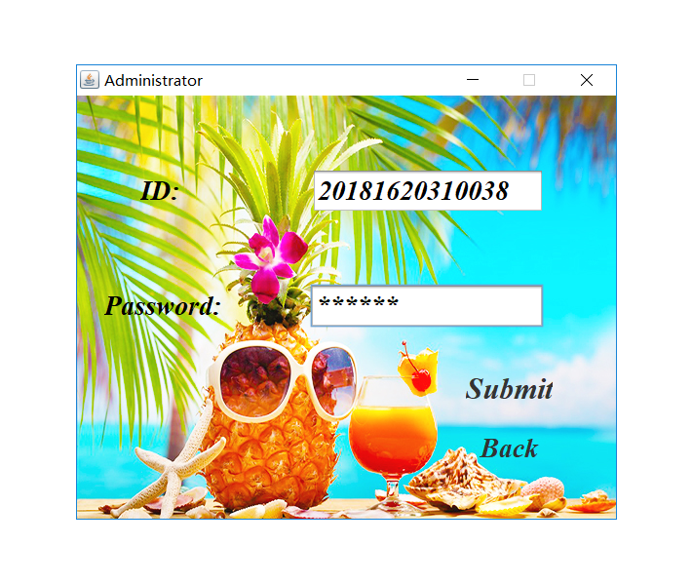

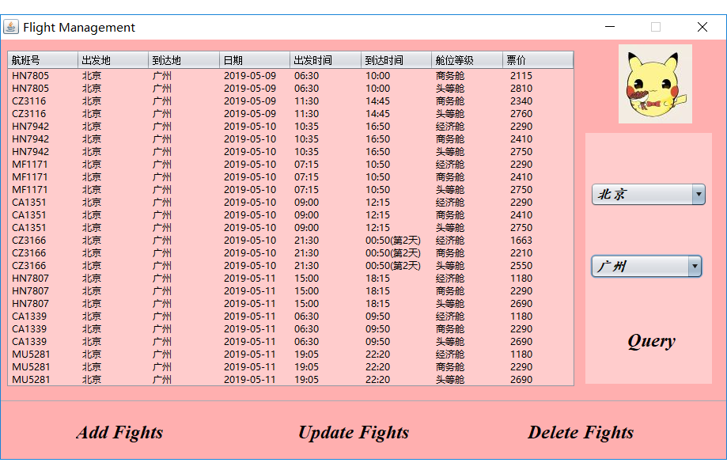

**Add Flight module**

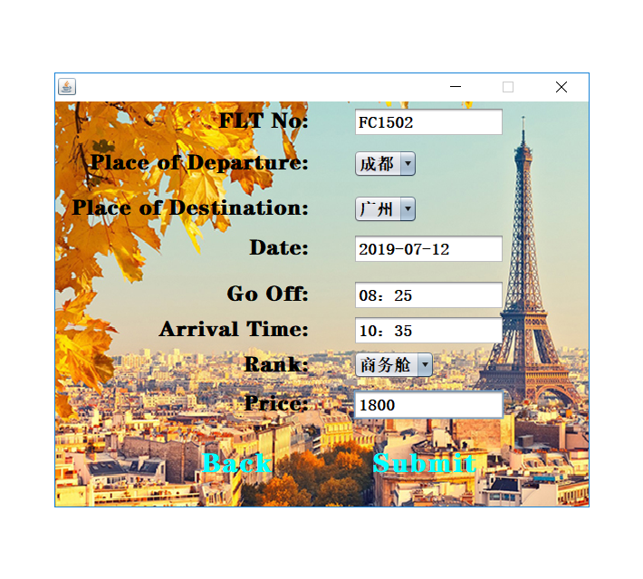

**Update Flight module**

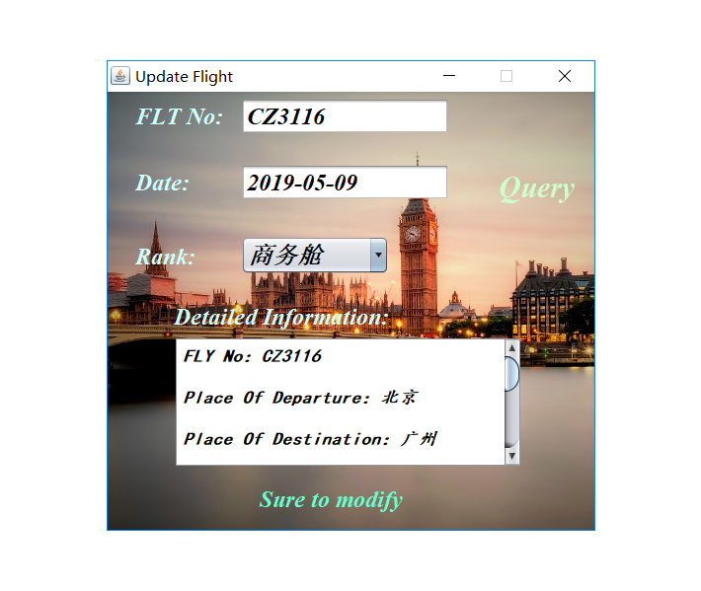

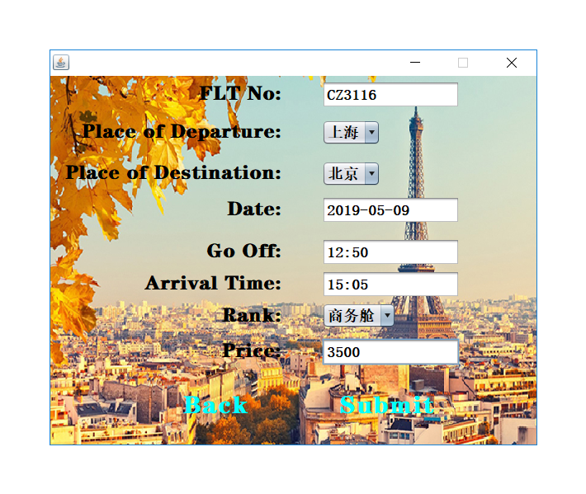

**Delete Flight module**

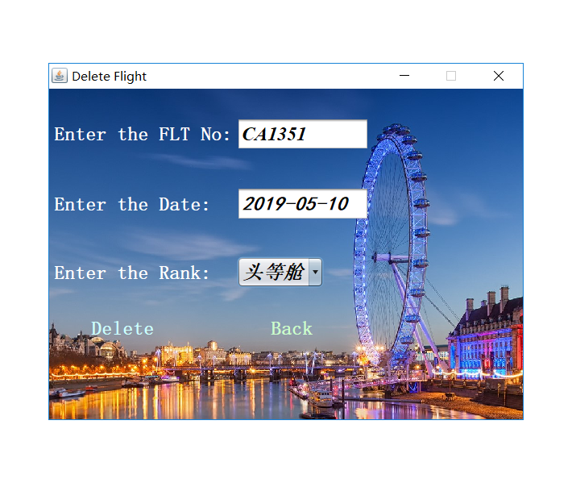

**Skip the Login and Book Directly Module**

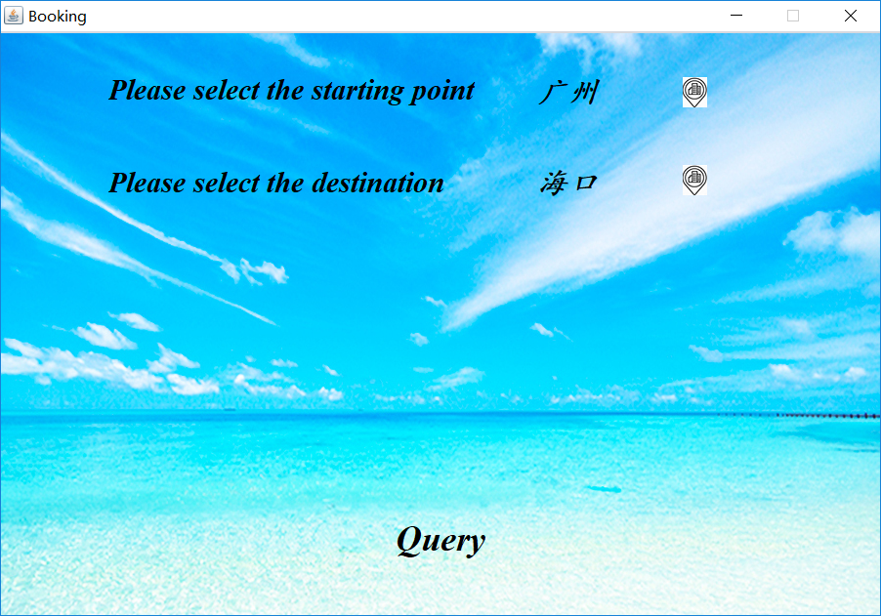

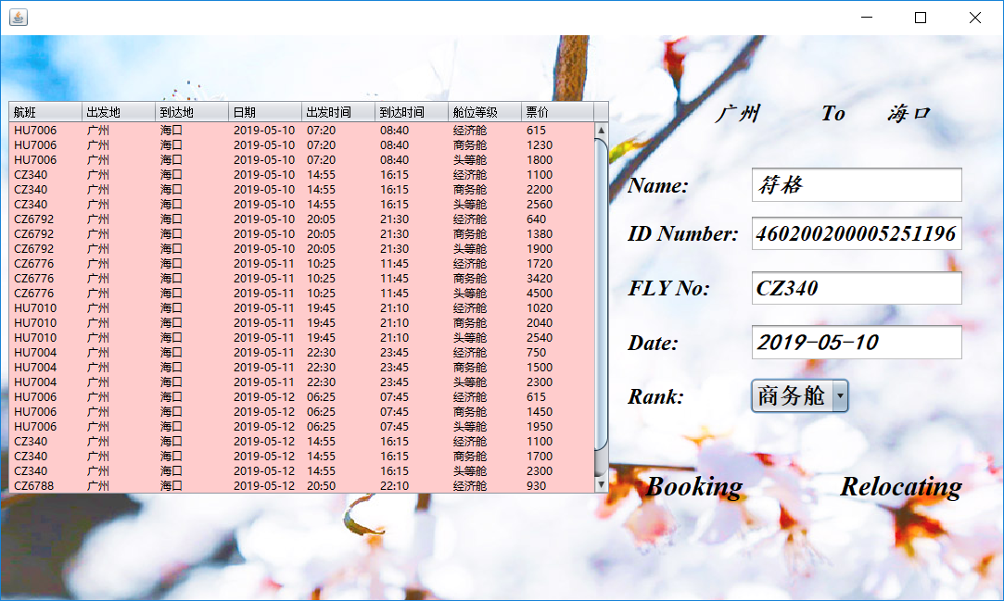

**Code of Connection1.java**

package inquire;

import java.sql.*;

public class Connection1 {

static private Connection conn;//建立数据库连接类，给其他类调用

public static Connection getConnection() throws Exception

{

String url="jdbc:mysql://localhost:3306/flight";

String user="root";

String passwd="abc123";

try

{

Class.forName("com.mysql.jdbc.Driver");

conn=DriverManager.getConnection(url, user, passwd);

if(conn!=null)

{

System.out.println("Succeed to Connect to Mysql.");

}

}catch(ClassNotFoundException e)

{

System.out.println("Fail to connect to Mysql.");

}

catch (SQLException e) {

System.out.println("Fail to connect to Mysql.");

}

return conn;

}

}

**Code of Login_Interface.java**

package inquire;

import java.awt.*;

import javax.swing.*;

import java.sql.*;

public class Login_Interface extends javax.swing.JFrame {

String name,mobile,point; //用于下文，将数据库中的姓名，电话号码,个人积分赋给name，mobile,point

Container ct; //用于设置背景

BackgroundPanel bgp;//用于设置背景

class BackgroundPanel extends JPanel

{

Image im;

public BackgroundPanel(Image im)

{

this.im=im;

this.setOpaque(true); //背景类，用于下文设置背景

}

public void paintComponent(Graphics g)

{

super.paintComponents(g);

g.drawImage(im,0,0,this.getWidth(),this.getHeight(),this);

}

}

public Login_Interface()

{

initComponents();

ct=this.getContentPane();

this.setLayout(null);

bgp=new BackgroundPanel((new ImageIcon("C:\\Users\\HAIER\\Documents\\NetBeansProjects\\inquire\\src\\newpackage\\login.jpg")).getImage());//设置背景

bgp.setBounds(0, 0, 1300, 700);

ct.add(bgp);

}

private void jLabel6MouseClicked(java.awt.event.MouseEvent evt) {

Retrieve_Password r= new Retrieve_Password();

r.setVisible(true);

r.setLocationRelativeTo(null); //打开Retrieve_password界面，并关闭此Login_Interface界面

dispose();

}

private void t1ActionPerformed(java.awt.event.ActionEvent evt) {

}

private void l8MouseClicked(java.awt.event.MouseEvent evt) {

try

{

Connection conn1=Connection1.getConnection(); //连接数据库

String sql="select * from user where User_Name=? and Password=?";

PreparedStatement pst=conn1.prepareStatement(sql);

pst.setString(1,t1.getText()); //接收User name

pst.setString(2,t2.getText()); //接收Password

ResultSet rs=pst.executeQuery();

if(rs.next()) /*如果User name与Password正确，从数据库中得到此用户的姓名与手机号码，并打开Personal_Center界面，

将用户名，姓名与手机号码显示在Personal_Center上，并将密码传到Personal_Center中，用于进一步传给Revamp_informatization中去，关闭此登陆界面*/

{

name=rs.getString("Full_Name");

mobile=rs.getString("Phone_number");

point=rs.getString("Point");

Personal_Center jf=new Personal_Center(t1.getText(),name,mobile,t2.getText(),point);

jf.setVisible(true);

jf.setLocationRelativeTo(null);

dispose();

}

else if(t1.getText().length()==0)

{

JOptionPane.showMessageDialog(null,"请输入用户名！","错误！！！",JOptionPane.ERROR_MESSAGE);//User name为空时，显示错误

}

else if(t2.getText().length()==0)

{

JOptionPane.showMessageDialog(null,"请输入密码！","错误！！！",JOptionPane.ERROR_MESSAGE);//Password为空时，显示错误

}

else

{

JOptionPane.showMessageDialog(null,"您的账号或密码错误！","错误！！！",JOptionPane.ERROR_MESSAGE);//User name或Password输入错误时，显示错误

}

}

catch (Exception e)

{

e.printStackTrace();

}

}

private void l10MouseClicked(java.awt.event.MouseEvent evt) {

dispose();

New_User d=new New_User(); //打开New user界面，并关闭此登陆界面

d.setVisible(true);

d.setLocationRelativeTo(null);

}

private void l11MouseClicked(java.awt.event.MouseEvent evt) {

Administrator adt=new Administrator();

adt.show(); //打开Administrator界面，并关闭此登陆界面

adt.setLocationRelativeTo(null);

dispose();

}

private void l9MouseClicked(java.awt.event.MouseEvent evt) {

dispose();

Booking b=new Booking(1); //打开Booking界面，并关闭此登陆界面，1代表新用户

b.setVisible(true);

b.setLocationRelativeTo(null);

}

public static void main(String args[]) {

java.awt.EventQueue.invokeLater(new Runnable() {

public void run()

{

JFrame j=new Login_Interface();

j.setVisible(true);

j.setLocationRelativeTo(null);

}

});

}

// Variables declaration - do not modify

private javax.swing.JLabel jLabel1;

private javax.swing.JLabel jLabel2;

private javax.swing.JLabel jLabel6;

private javax.swing.JLabel jLabel7;

private javax.swing.JLabel l10;

private javax.swing.JLabel l11;

private javax.swing.JLabel l8;

private javax.swing.JLabel l9;

private javax.swing.JTextField t1;

private javax.swing.JPasswordField t2;

// End of variables declaration

**Code of Personal_Center.java**

package inquire;

import java.awt.*;

import javax.swing.*;

import java.sql.*;

import java.util.*;

public class Personal_Center extends javax.swing.JFrame {

Container ct; //用于设置背景

BackgroundPanel bgp;//用于设置背景

String m,e,n; //用于下文构造函数中的赋值

class BackgroundPanel extends JPanel

{

Image im;

public BackgroundPanel(Image im)

{

this.im=im;

this.setOpaque(true); //背景类，用于下文设置背景

}

public void paintComponent(Graphics g)

{

super.paintComponents(g);

g.drawImage(im,0,0,this.getWidth(),this.getHeight(),this);

}

}

public Personal_Center(String a,String b,String c,String d,String f) { //重写构造函数，接收来自Login_Interface或New_user的用户名，姓名，电话号码,个人积分

initComponents();

ct=this.getContentPane();

this.setLayout(null);

bgp=new BackgroundPanel((new ImageIcon("C:\\Users\\HAIER\\Documents\\NetBeansProjects\\inquire\\src\\newpackage\\Personal Center1.jpg")).getImage());//设置背景

bgp.setBounds(0, 0, 576, 464);

ct.add(bgp);

q1.setText("Dear "+a); //显示用户名

l1.setText(b); //显示姓名

l2.setText(c); //显示电话号码

l3.setText(f); //显示个人积分

m=a; //将用户名赋给变量m，用于进一步传值给Modify_Information

e=d; //将密码赋给变量e，用于进一步传值给Modify_Information

n=f; //将个人积分赋给变量n,用于进一步传值给Modify_Information

}

private void l4MouseClicked(java.awt.event.MouseEvent evt) {

dispose();

Booking d=new Booking(0); //0代表会员

d.setVisible(true); //打开Booking界面，并关闭此Personal_Center界面

d.setLocationRelativeTo(null);

}

private void l7MouseClicked(java.awt.event.MouseEvent evt) {

Login_Interface e=new Login_Interface();

e.setVisible(true); //打开Login_Interface，并关闭此Personal_Center界面

e.setLocationRelativeTo(null);

dispose();

}

private void l6MouseClicked(java.awt.event.MouseEvent evt) {

dispose();

Modify_Information q=new Modify_Information(m,l2.getText(),e,l1.getText(),n);//打开Modify_Information界面，将用户名，手机号码，密码，姓名个人积分传给Modify_Information,并关闭此Personal_Center界面

q.show();

q.setLocationRelativeTo(null);

}

public static void main(String args[]) {

java.awt.EventQueue.invokeLater(new Runnable() {

public void run() {

}

});

}

// Variables declaration - do not modify

private javax.swing.JLabel jLabel2;

private javax.swing.JLabel jLabel3;

private javax.swing.JLabel jLabel4;

private javax.swing.JLabel l1;

private javax.swing.JLabel l2;

private javax.swing.JLabel l3;

private javax.swing.JLabel l4;

private javax.swing.JLabel l6;

private javax.swing.JLabel l7;

private javax.swing.JLabel q1;

// End of variables declaration

}

**Code of Booking.java**

package inquire;

import java.awt.*;

import javax.swing.*;

public class Booking extends javax.swing.JFrame

{

int i=0;//用于下文判断是出发地还是到达地

int m;//用于下文赋值

private JPanel imagePanel; //用于下文设置背景

private ImageIcon background1; //用于下文设置背景

private ImageIcon background2; //用于下文设置背景

public Booking(int i)//重写构造函数，得到来自Login_Interfa或Personal_Center的值，判断是新用户还是会员，打开对应的Result界面

{

initComponents();

remove(p1);

p1.setVisible(false);

background1 = new ImageIcon("C:\\Users\\HAIER\\Documents\\NetBeansProjects\\inquire\\src\\newpackage\\Booking1.jpg");// 背景图片

background2 = new ImageIcon("C:\\Users\\HAIER\\Documents\\NetBeansProjects\\inquire\\src\\newpackage\\Booking2.jpg");// Panel图片

JLabel label = new JLabel(background1);

label.setBounds(0, 0, 900,605);

imagePanel = (JPanel) getContentPane(); //设置背景

imagePanel.setOpaque(false);

imagePanel.setLayout(null);

getLayeredPane().setLayout(null);

getLayeredPane().add(label, new Integer(Integer.MIN_VALUE));

JLabel a = new JLabel(background2); //设置Panel背景

a.setBounds(0, 0,600,291);

p1.add(a,-1);

m=i;

}

//下文的q1——q8MouseClicked，均为将地点显示在界面上，并用变量i，将第一次点击与第二次点击的地点分别显示在出发地与到达地上，并在选择后将Panel隐藏

private void q1MouseClicked(java.awt.event.MouseEvent evt) {

p1.setVisible(false);

if(i==0)

{

String str=q1.getText();

l3.setText(str);

i++;

}

else if(i==1)

{

String str=q1.getText();

l4.setText(str);

}

}

private void q2MouseClicked(java.awt.event.MouseEvent evt) {

p1.setVisible(false);

if(i==0)

{

String str=q2.getText();

l3.setText(str);

i++;

}

else if(i==1)

{

String str=q2.getText();

l4.setText(str);

}

}

private void q3MouseClicked(java.awt.event.MouseEvent evt) {

p1.setVisible(false);

if(i==0)

{

String str=q3.getText();

l3.setText(str);

i++;

}

else if(i==1)

{

String str=q3.getText();

l4.setText(str);

}

}

private void q4MouseClicked(java.awt.event.MouseEvent evt) {

p1.setVisible(false);

if(i==0)

{

String str=q4.getText();

l3.setText(str);

i++;

}

else if(i==1)

{

String str=q4.getText();

l4.setText(str);

}

}

private void q5MouseClicked(java.awt.event.MouseEvent evt) {

p1.setVisible(false);

if(i==0)

{

String str=q5.getText();

l3.setText(str);

i++;

}

else if(i==1)

{

String str=q5.getText();

l4.setText(str);

}

}

private void q8MouseClicked(java.awt.event.MouseEvent evt) {

p1.setVisible(false);

if(i==0)

{

String str=q8.getText();

l3.setText(str);

i++;

}

else if(i==1)

{

String str=q8.getText();

l4.setText(str);

}

}

private void q7MouseClicked(java.awt.event.MouseEvent evt) {

p1.setVisible(false);

if(i==0)

{

String str=q7.getText();

l3.setText(str);

i++;

}

else if(i==1)

{

String str=q7.getText();

l4.setText(str);

}

}

private void q6MouseClicked(java.awt.event.MouseEvent evt) {

p1.setVisible(false);

if(i==0)

{

String str=q6.getText();

l3.setText(str);

i++;

}

else if(i==1)

{

String str=q6.getText();

l4.setText(str);

}

}

private void l5MouseClicked(java.awt.event.MouseEvent evt) {

if(l3.getText().length()==0)

{

JOptionPane.showMessageDialog(null,"请选择出发地！","错误！！！",JOptionPane.ERROR_MESSAGE); //如果没有选择出发地，显示错误

}

else if(l4.getText().length()==0)

{

JOptionPane.showMessageDialog(null,"请选择到达地！","错误！！！",JOptionPane.ERROR_MESSAGE); //如果没有选择到达地，显示错误

}

else if(l4.getText()==l3.getText())

{

JOptionPane.showMessageDialog(null,"出发地不能与到达地一致！","错误！！！",JOptionPane.ERROR_MESSAGE); //如果出发点与到达地一样，显示错误

}

else

{

if(m==0)

{

Result1 w=new Result1(l3.getText(),l4.getText()); //会员，如果出发点与到达地选择正确，打开Result1界面，并关闭此Booking界面

w.show();

w.setLocationRelativeTo(null);

dispose();

}

else if(m==1)

{

Result2 w=new Result2(l3.getText(),l4.getText()); //新用户，如果出发点与到达地选择正确，打开Result2界面，并关闭此Booking界面

w.show();

w.setLocationRelativeTo(null);

dispose();

}

}

}

private void l6MouseClicked(java.awt.event.MouseEvent evt) {

// TODO add your handling code here:

}

private void l7MouseClicked(java.awt.event.MouseEvent evt) {

// TODO add your handling code here:

}

private void l1MouseClicked(java.awt.event.MouseEvent evt) {

add(p1); //将隐藏的Panel，显示出来

p1.setVisible(true);

}

private void l2MouseClicked(java.awt.event.MouseEvent evt) {

if(l3.getText().length()==0)

{

JOptionPane.showMessageDialog(null,"请先选择出发地！","错误！！！",JOptionPane.ERROR_MESSAGE);//如果先选择到达地，显示错误

}

else

{

add(p1); //将隐藏的Panel，显示出来

p1.setVisible(true);

}

}

public static void main(String args[]) {

java.awt.EventQueue.invokeLater(new Runnable() {

public void run()

{

}

});

}

// Variables declaration - do not modify

private javax.swing.JLabel l1;

private javax.swing.JLabel l2;

private javax.swing.JLabel l3;

private javax.swing.JLabel l4;

private javax.swing.JLabel l5;

private javax.swing.JLabel l6;

private javax.swing.JLabel l7;

private javax.swing.JPanel p1;

private javax.swing.JLabel q1;

private javax.swing.JLabel q2;

private javax.swing.JLabel q3;

private javax.swing.JLabel q4;

private javax.swing.JLabel q5;

private javax.swing.JLabel q6;

private javax.swing.JLabel q7;

private javax.swing.JLabel q8;

// End of variables declaration

}

**Code of Result1.java**

package inquire;

import java.awt.*;

import java.sql.*;

import java.util.*;

import javax.swing.table.*;

import javax.swing.*;

public class Result1 extends javax.swing.JFrame {

Container ct; //用于设置背景

BackgroundPanel bgp; //用于设置背景

class BackgroundPanel extends JPanel

{

Image im;

public BackgroundPanel(Image im)

{

this.im=im;

this.setOpaque(true); //背景类，用于下文设置背景

}

public void paintComponent(Graphics g)

{

super.paintComponents(g);

g.drawImage(im,0,0,this.getWidth(),this.getHeight(),this);

}

}

public Result1(String a,String b)

{

initComponents();

p1.setText(a);//接收来自Booking的出发地，并显示在界面上

p2.setText(b);//接收来自Booking的到达地，并显示在界面上

ct=this.getContentPane();

this.setLayout(null);

bgp=new BackgroundPanel((new ImageIcon("C:\\Users\\HAIER\\Desktop\\inquire\\src\\newpackage\\Result.jpg")).getImage());//设置背景

bgp.setBounds(0, 0, 1300, 700);

ct.add(bgp);

try

{

Connection conn1=Connection1.getConnection(); //连接数据库

String sql="select * from hangban where place_of_departure=? and place_of_destination=? ";

PreparedStatement pst=conn1.prepareStatement(sql);

pst.setString(1,p1.getText()); //接收出发地

pst.setString(2,p2.getText()); //接收到达地

ResultSet rst=pst.executeQuery();

ResultSetMetaData rsmt = rst.getMetaData();

String x[] = null;

int columnCount = rsmt.getColumnCount();

DefaultTableModel tm = (DefaultTableModel) jTable.getModel();//让查询到的数据显示在表格

tm.setColumnCount(0);

tm.setRowCount(0);

tm.addColumn("航班");//添加列名

tm.addColumn("出发地");

tm.addColumn("到达地");

tm.addColumn("日期");

tm.addColumn("出发时间");

tm.addColumn("到达时间");

tm.addColumn("舱位等级");

tm.addColumn("票价");

while(rst.next())

{

for (int i = 1; i <= columnCount; i++)

{

x = new String[columnCount];

}

for (int s = 0; s < columnCount; s++)

{

x[s] = rst.getString(s + 1);

}

tm.addRow(x);

}

}

catch(Exception ex)

{

ex.printStackTrace();

}

}

private void l2MouseClicked(java.awt.event.MouseEvent evt) {

try

{

Connection conn1=Connection1.getConnection(); //连接数据库

String sql1="select * from hangban where FLT_NO=? and date=? and rank=?";

PreparedStatement pst1=conn1.prepareStatement(sql1);

pst1.setString(1,t1.getText());

pst1.setString(2,t2.getText());

pst1.setString(3,jc1.getSelectedItem().toString());

ResultSet rst=pst1.executeQuery();

if(rst.next())//数据正确后，将航班的具体信息赋给变量abcdefgh，用于进一步传给Booking_Success界面

{

String a,b,c,d,e,f,g,h;

a=rst.getString("FLT_NO");

b=rst.getString("place_of_departure");

c=rst.getString("place_of_destination");

d=rst.getString("date");

e=rst.getString("go_off");

f=rst.getString("arrival_time");

g=rst.getString("rank");

h=rst.getString("price");

Successful_Booking q=new Successful_Booking(a,b,c,d,e,f,g,h,0); //打开Booking_Success界面，关闭此Result1界面

q.show();

q.setLocationRelativeTo(null);

dispose();

}

else if(t1.getText().length()==0)

{

JOptionPane.showMessageDialog(null,"请输入航班号！","错误！！！",JOptionPane.ERROR_MESSAGE);//Fly No为空时，显示错误

}

else if(t2.getText().length()==0)

{

JOptionPane.showMessageDialog(null,"请输入日期！","错误！！！",JOptionPane.ERROR_MESSAGE);//date为空时，显示错误

}

else if(jc1.getSelectedItem().toString().length()==0)

{

JOptionPane.showMessageDialog(null,"请输入舱位等级！","错误！！！",JOptionPane.ERROR_MESSAGE);//rank为空时，显示错误

}

else

{

JOptionPane.showMessageDialog(null,"航班号或日期或舱位等级错误！","错误！！！",JOptionPane.ERROR_MESSAGE);//Fly No或rank错误时，显示错误

}

}

catch (Exception ex)

{

ex.printStackTrace();

}

}

private void l6MouseClicked(java.awt.event.MouseEvent evt) {

dispose();

Booking b=new Booking(0); //打开Booking界面，并关闭此登陆界面

b.setVisible(true);

b.setLocationRelativeTo(null);

}

/**

* @param args the command line arguments

*/

public static void main(String args[]) {

java.awt.EventQueue.invokeLater(new Runnable() {

public void run() {

Result1 c=new Result1(null,null);

c.setVisible(true);

}

});

}

// Variables declaration - do not modify

private javax.swing.JButton jButton1;

private javax.swing.JScrollPane jScrollPane1;

private javax.swing.JTable jTable;

private javax.swing.JComboBox<String> jc1;

private javax.swing.JLabel l1;

private javax.swing.JLabel l2;

private javax.swing.JLabel l3;

private javax.swing.JLabel l4;

private javax.swing.JLabel l5;

private javax.swing.JLabel l6;

private javax.swing.JLabel p1;

private javax.swing.JLabel p2;

private javax.swing.JTextField t1;

private javax.swing.JTextField t2;

// End of variables declaration

}

**Code of Successful_Booking.java**

package inquire;

import java.awt.*;

import java.sql.*;

import java.util.*;

import javax.swing.*;

public class Successful_Booking extends javax.swing.JFrame {

int m;//用于下文赋值，判断是新用户还是会员

Container ct; //用于设置背景

BackgroundPanel bgp;//用于设置背景

class BackgroundPanel extends JPanel

{

Image im;

public BackgroundPanel(Image im)

{

this.im=im;

this.setOpaque(true); //背景类，用于下文设置背景

}

public void paintComponent(Graphics g)

{

super.paintComponents(g);

g.drawImage(im,0,0,this.getWidth(),this.getHeight(),this);

}

}

public Successful_Booking(String p1,String p2,String p3,String p4,String p5,String p6,String p7,String p8,int i) //重写构造函数，接收来自Result的航班号，出发地，到达地，日期，出发时间，到达时间，舱位等级，价格

{

initComponents();

jf2.setText("FLY No："+p1+"\n\n"+"Place Of Departure："+p2+"\n\n"

+"Place Of Destination："+p3+"\n\n"+"Date："+p4+"\n\n"+"Go Off："+p5+"\n\n"+"Arrival Time："+p6+"\n\n"+"Rank："+p7+"\n\n"+"Price："+p8+"\n\n");

ct=this.getContentPane();

this.setLayout(null);

bgp=new BackgroundPanel((new ImageIcon("C:\\Users\\HAIER\\Desktop\\inquire\\src\\newpackage\\Successful booking.jpg")).getImage());//设置背景

bgp.setBounds(0, 0, 438, 512);

ct.add(bgp);

m=i;

}

private void jLabel2MouseClicked(java.awt.event.MouseEvent evt) {

if(m==0)

{

dispose();

Booking b=new Booking(0); //打开Booking界面，并关闭此登陆界面

b.setVisible(true);

b.setLocationRelativeTo(null);

}

if(m==1)

{

dispose();

Booking b=new Booking(1); //打开Booking界面，并关闭此登陆界面

b.setVisible(true);

b.setLocationRelativeTo(null);

}

}

private void jLabel3MouseClicked(java.awt.event.MouseEvent evt) {

System.exit(0);//退出

}

/**

* @param args the command line arguments

*/

public static void main(String args[]) {

java.awt.EventQueue.invokeLater(new Runnable() {

public void run()

{

}

});

}

// Variables declaration - do not modify

private javax.swing.JLabel jLabel2;

private javax.swing.JLabel jLabel3;

private javax.swing.JLabel jLabel4;

private javax.swing.JLabel jLabel5;

private javax.swing.JScrollPane jScrollPane2;

private javax.swing.JTextArea jf2;

// End of variables declaration

}

**Code of Modify_Information.java**

package inquire;

import java.sql.*;

import javax.swing.*;

import java.awt.*;

import java.util.*;

/**

*

* @author HAIER

*/

public class Modify_Information extends javax.swing.JFrame {

String n,m,x; //用于下文赋值

Container ct; //用于设置背景

BackgroundPanel bgp; //用于设置背景

class BackgroundPanel extends JPanel

{

Image im;

public BackgroundPanel(Image im)

{

this.im=im;

this.setOpaque(true);

}

public void paintComponent(Graphics g) //背景类，用于下文设置背景

{

super.paintComponents(g);

g.drawImage(im,0,0,this.getWidth(),this.getHeight(),this);

}

}

public Modify_Information(String a,String b,String c,String d,String e) { //重写构造函数，接收来自Personal_Center的用户名，手机号码，密码，姓名

initComponents();

ct=this.getContentPane();

this.setLayout(null);

bgp=new BackgroundPanel((new ImageIcon("C:\\Users\\HAIER\\Documents\\NetBeansProjects\\inquire\\src\\newpackage\\Revamp_Informatization.jpg")).getImage());//设置背景

bgp.setBounds(0, 0, 811, 485);

ct.add(bgp);

t1.setText(a); //将原用户名显示

t2.setText(b); //将原手机号码显示

t3.setText(c); //将原密码显示

n=d; //将姓名赋给变量n

m=a; //将原用户名赋给变量m

x=e; //将原个人积分赋给变量x

}

public static boolean isNumerict3(String str)

{

for (int i = 0; i < str.length(); i++)

{

if (!Character.isDigit(str.charAt(i))) //判断电话号码是否是数字

{

return false;

}

}

return true;

}

public static boolean isNumerict4t5(String str)

{

for (int i = 0; i < str.length(); i++)

{

if ((str.charAt(i)>=19968&&str.charAt(i)<=40869)||(str.charAt(i)>=0&&str.charAt(i)<=47)||(str.charAt(i)>=58&&str.charAt(i)<=64)

||(str.charAt(i)>=91&&str.charAt(i)<=96)||(str.charAt(i)>=123&&str.charAt(i)<=127)) //判断用户名，密码是否包含汉字，符号

{

return false;

}

}

return true;

}

private void jLabel5MouseClicked(java.awt.event.MouseEvent evt) {

if(t1.getText().length()==0)

{

JOptionPane.showMessageDialog(null, "请输入用户名！","错误！！！",JOptionPane.ERROR_MESSAGE); //用户名为空时，显示错误

}

else if(!isNumerict4t5(t1.getText()))

{

JOptionPane.showMessageDialog(null, "用户名仅能为数字，字母！","错误！！！",JOptionPane.ERROR_MESSAGE); //用户名不符合规定时，显示错误

}

else if(t2.getText().length()==0)

{

JOptionPane.showMessageDialog(null, "请输入电话号码！","错误！！！",JOptionPane.ERROR_MESSAGE); //电话号码为空时，显示错误

}

else if(t2.getText().length()>11||t2.getText().length()<11)

{

JOptionPane.showMessageDialog(null, "仅接收十一位电话号码！","错误！！！",JOptionPane.ERROR_MESSAGE); //电话号码不符合规定时，显示错误

}

else if(t2.getText().length()==11&&(!isNumerict3(t2.getText())))

{

JOptionPane.showMessageDialog(null, "电话号码仅能为数字！","错误！！！",JOptionPane.ERROR_MESSAGE); //电话号码不符合规定时，显示错误

}

else if(t3.getText().length()==0)

{

JOptionPane.showMessageDialog(null, "请输入密码！","错误！！！",JOptionPane.ERROR_MESSAGE); //密码为空时，显示错误

}

else if(!isNumerict4t5(t3.getText()))

{

JOptionPane.showMessageDialog(null, "密码仅能为数字，字母！","错误！！！",JOptionPane.ERROR_MESSAGE);//密码不符合规定时，显示错误

}

else if(!(t3.getText().equals(t4.getText())))

{

JOptionPane.showMessageDialog(null, "您输入的密码不一致！","错误！！！",JOptionPane.ERROR_MESSAGE);

}

else

{

try

{

Connection conn1=Connection1.getConnection(); //连接数据库

String sql="update user set User_Name=?,Phone_number=?,Password=? where User_Name=? "; //更新

PreparedStatement pst=conn1.prepareStatement(sql);

pst.setString(1,t1.getText()); //接收新用户名

pst.setString(2,t2.getText()); //接收新电话号码

pst.setString(3,t3.getText()); //接收新密码

pst.setString(4,m); //

int i=pst.executeUpdate();

if(i>0)

{

dispose();

JOptionPane.showMessageDialog(null,"数据已更新成功","修改成功！",JOptionPane.ERROR_MESSAGE);

Personal_Center pc=new Personal_Center(t1.getText(),n,t2.getText(),null,x); //当数据正确，更新成功时，打开Personal_Center界面，将新用户名，原姓名，新电话号码,原个人积分显示在Personal_Center上，关闭此Modify_Information界面

pc.setVisible(true);

pc.setLocationRelativeTo(null);

}

}

catch(Exception e)

{

e.printStackTrace();

}

}

}

/**

* @param args the command line arguments

*/

public static void main(String args[]) {

java.awt.EventQueue.invokeLater(new Runnable() {

public void run()

{

}

});

}

// Variables declaration - do not modify

private javax.swing.JLabel jLabel1;

private javax.swing.JLabel jLabel2;

private javax.swing.JLabel jLabel3;

private javax.swing.JLabel jLabel4;

private javax.swing.JLabel jLabel5;

private javax.swing.JLabel jLabel6;

private javax.swing.JLabel jLabel7;

private javax.swing.JLabel jLabel8;

private javax.swing.JTextField t1;

private javax.swing.JTextField t2;

private javax.swing.JTextField t3;

private javax.swing.JTextField t4;

// End of variables declaration

}

**Code of New_User.java**

package inquire;

import java.awt.*;

import javax.swing.*;

import java.sql.*;

import java.util.*;

public class New_User extends javax.swing.JFrame {

Container ct; //用于设置背景

BackgroundPanel bgp; //用于设置背景

class BackgroundPanel extends JPanel

{

Image im;

public BackgroundPanel(Image im)

{

this.im=im;

this.setOpaque(true);

}

public void paintComponent(Graphics g) //背景类，用于下文设置背景

{

super.paintComponents(g);

g.drawImage(im,0,0,this.getWidth(),this.getHeight(),this);

}

}

public New_User()

{

initComponents();

ct=this.getContentPane();

this.setLayout(null);

bgp=new BackgroundPanel((new ImageIcon("C:\\Users\\HAIER\\Desktop\\inquire\\src\\newpackage\\new user.jpg")).getImage());//设置背景

bgp.setBounds(0, 0, 795, 584);

ct.add(bgp);

}

public static boolean isNumerict2(String str)

{

for (int i = 0; i < str.length()-1; i++)

{

if (!Character.isDigit(str.charAt(i))) //判断身份证的前十七位是否是数字

{

return false;

}

}

return true;

}

public static boolean isNumerict3(String str)

{

for (int i = 0; i < str.length(); i++)

{

if (!Character.isDigit(str.charAt(i))) //判断电话号码是否是数字

{

return false;

}

}

return true;

}

public static boolean isNumerict4t5(String str)

{

for (int i = 0; i < str.length(); i++)

{

if ((str.charAt(i)>=19968&&str.charAt(i)<=40869)||(str.charAt(i)>=0&&str.charAt(i)<=47)||(str.charAt(i)>=58&&str.charAt(i)<=64)

||(str.charAt(i)>=91&&str.charAt(i)<=96)||(str.charAt(i)>=123&&str.charAt(i)<=127)) //判断用户名，密码是否包含汉字，符号

{

return false;

}

}

return true;

}

private void q5ActionPerformed(java.awt.event.ActionEvent evt) {

// TODO add your handling code here:

}

private void jLabel13MouseClicked(java.awt.event.MouseEvent evt) {

if(q1.getText().length()==0)

{

JOptionPane.showMessageDialog(null, "请输入姓名！","错误！！！",JOptionPane.ERROR_MESSAGE); //姓名为空时，显示错误

}

else if(!q1.getText().matches("[\\u4E00-\\u9FA5]+"))

{

JOptionPane.showMessageDialog(null, "姓名仅接收汉字！","错误！！！",JOptionPane.ERROR_MESSAGE); //姓名不符合规定时，显示错误

}

else if(q2.getText().length()==0)

{

JOptionPane.showMessageDialog(null, "请输入身份证号！","错误！！！",JOptionPane.ERROR_MESSAGE); //身份证号为空时，显示错误

}

else if(q2.getText().length()>18||q2.getText().length()<18)

{

JOptionPane.showMessageDialog(null, "仅接收十八位身份证号！","错误！！！",JOptionPane.ERROR_MESSAGE);//身份证号不符合规定时，显示错误

}

else if(q2.getText().length()==18&&(!isNumerict2(q2.getText())))

{

JOptionPane.showMessageDialog(null, "前十七位只能为数字","错误！！！",JOptionPane.ERROR_MESSAGE); //身份证号不符合规定时，显示错误

}

else if(q2.getText().length()==18&&(((int)(q2.getText().charAt(17))<48||((int)(q2.getText().charAt(17))>57

&&(int)(q2.getText().charAt(17))<88))||(int)(q2.getText().charAt(17))>88))

{

JOptionPane.showMessageDialog(null, "最后一位只能为数字或大写字母X","错误！！！",JOptionPane.ERROR_MESSAGE); //身份证号不符合规定时，显示错误

}

else if(q3.getText().length()==0)

{

JOptionPane.showMessageDialog(null, "请输入电话号码！","错误！！！",JOptionPane.ERROR_MESSAGE); //电话号码为空时，显示错误

}

else if(q3.getText().length()>11||q3.getText().length()<11)

{

JOptionPane.showMessageDialog(null, "仅接收十一位电话号码！","错误！！！",JOptionPane.ERROR_MESSAGE); //电话号码不符合规定时，显示错误

}

else if(q3.getText().length()==11&&(!isNumerict3(q3.getText())))

{

JOptionPane.showMessageDialog(null, "电话号码仅能为数字","错误！！！",JOptionPane.ERROR_MESSAGE); //电话号码不符合规定时，显示错误

}

else if(q4.getText().length()==0)

{

JOptionPane.showMessageDialog(null, "请输入用户名！","错误！！！",JOptionPane.ERROR_MESSAGE); //用户名为空时，显示错误

}

else if(!isNumerict4t5(q4.getText()))

{

JOptionPane.showMessageDialog(null, "用户名仅能为数字，字母！","错误！！！",JOptionPane.ERROR_MESSAGE); //用户名不符合规定时，显示错误

}

else if(q5.getText().length()==0)

{

JOptionPane.showMessageDialog(null, "请输入密码！","错误！！！",JOptionPane.ERROR_MESSAGE); //密码为空时，显示错误

}

else if(!isNumerict4t5(q5.getText()))

{

JOptionPane.showMessageDialog(null, "密码仅能为数字，字母！","错误！！！",JOptionPane.ERROR_MESSAGE);//密码不符合规定时，显示错误

}

else if(t6.getText().length()==0)

{

JOptionPane.showMessageDialog(null, "请再次确认您的密码！","错误！！！",JOptionPane.ERROR_MESSAGE); //再次确认密码为空时，显示错误

}

else if(!(t6.getText().equals(q5.getText())))

{

JOptionPane.showMessageDialog(null, "您输入的密码不一致！","错误！！！",JOptionPane.ERROR_MESSAGE);//再次确认密码不符合规定时，显示错误

}

else

{

try

{

Connection conn1=Connection1.getConnection(); //连接数据库

String sql="insert into user values (?,?,?,?,?,?)"; //将新用户的用户名，密码，身份证号，电话号码，姓名,个人积分输入数据库

PreparedStatement pst=conn1.prepareStatement(sql);

pst.setString(1,q4.getText()); //接收用户名

pst.setString(2,q5.getText()); //接收密码

pst.setString(3,q2.getText()); //接收身份证号

pst.setString(4,q3.getText()); //接收电话号码

pst.setString(5,q1.getText()); //接收姓名

pst.setString(6,"0");

int i=pst.executeUpdate();

if(i>0)

{

dispose();

JOptionPane.showMessageDialog(this,"欢迎您加入海南第一航空！"); //当输入正确时，显示画面，并进入Personal_Center界面，关闭此New_user界面

Personal_Center pc=new Personal_Center(q4.getText(),q1.getText(),q3.getText(),null,"0"); //将用户名，姓名，电话号码传入Personal_Center中

pc.setVisible(true);

pc.setLocationRelativeTo(null);

}

}

catch(Exception e)

{

e.printStackTrace();

}

}

}

public static void main(String args[]) {

java.awt.EventQueue.invokeLater(new Runnable() {

public void run()

{

}

});

}

// Variables declaration - do not modify

private javax.swing.JLabel jLabel1;

private javax.swing.JLabel jLabel10;

private javax.swing.JLabel jLabel11;

private javax.swing.JLabel jLabel13;

private javax.swing.JLabel jLabel2;

private javax.swing.JLabel jLabel3;

private javax.swing.JLabel jLabel4;

private javax.swing.JLabel jLabel5;

private javax.swing.JLabel jLabel6;

private javax.swing.JLabel jLabel7;

private javax.swing.JLabel jLabel8;

private javax.swing.JLabel jLabel9;

private javax.swing.JTextField q1;

private javax.swing.JTextField q2;

private javax.swing.JTextField q3;

private javax.swing.JTextField q4;

private javax.swing.JTextField q5;

private javax.swing.JTextField t6;

// End of variables declaration

}

**Code of Retrieve_Password.java**

package inquire;

import java.awt.*;

import javax.swing.*;

import java.sql.*;

import java.util.*;

public class Retrieve_Password extends javax.swing.JFrame

{

Container ct; //用于设置背景

BackgroundPanel bgp;//用于设置背景

class BackgroundPanel extends JPanel

{

Image im;

public BackgroundPanel(Image im)

{

this.im=im; ////背景类，用于下文设置背景

this.setOpaque(true);

}

public void paintComponent(Graphics g)

{

super.paintComponents(g);

g.drawImage(im,0,0,this.getWidth(),this.getHeight(),this);

}

}

public Retrieve_Password()

{

initComponents();

ct=this.getContentPane();

this.setLayout(null);

bgp=new BackgroundPanel((new ImageIcon("C:\\Users\\HAIER\\Documents\\NetBeansProjects\\inquire\\src\\newpackage\\Retrieve password.jpg")).getImage());//设置背景

bgp.setBounds(0, 0, 614, 410);

ct.add(bgp);

}

private void t3ActionPerformed(java.awt.event.ActionEvent evt) {

// TODO add your handling code here:

}

private void l1MouseClicked(java.awt.event.MouseEvent evt) {

try

{

Connection conn1=Connection1.getConnection(); //连接数据库

String sql="select * from user where Full_Name=? and ID_Number=? and Phone_number=? "; //从数据库中查询Full Name，ID Number，Phone number

PreparedStatement pst=conn1.prepareStatement(sql);

pst.setString(1,t1.getText()); //接收Name

pst.setString(2,t2.getText()); //接收ID Number

pst.setString(3,t3.getText()); //接收Phone number

ResultSet rs=pst.executeQuery();

if(rs.next())

{

l.setText(rs.getString("Password")); //如果Name，ID Number，Phone number都正确，输出此用户的Password，显示在界面上

}

else if(t1.getText().length()==0)

{

JOptionPane.showMessageDialog(null,"请输入您的姓名！","错误！！！",JOptionPane.ERROR_MESSAGE);//如果Name为空，显示错误

}

else if(t2.getText().length()==0)

{

JOptionPane.showMessageDialog(null,"请输入您的身份证号！","错误！！！",JOptionPane.ERROR_MESSAGE);//如果ID Number为空，显示错误

}

else if(t3.getText().length()==0)

{

JOptionPane.showMessageDialog(null,"请输入您的电话号码！","错误！！！",JOptionPane.ERROR_MESSAGE);//如果Phone number为空，显示错误

}

else

{

JOptionPane.showMessageDialog(null,"账号或密码或电话号码错误！","错误！！！",JOptionPane.ERROR_MESSAGE);//如果Name，或ID Number或Phone number错误，显示错误

}

}

catch (Exception e)

{

e.printStackTrace();

}

}

private void l2MouseClicked(java.awt.event.MouseEvent evt) {

Login_Interface jf=new Login_Interface();

jf.setVisible(true);

jf.setLocationRelativeTo(null); //打开Login_Interface界面，并关闭此Retrieve password界面

dispose();

}

public static void main(String args[]) {

java.awt.EventQueue.invokeLater(new Runnable() {

public void run()

{

}

});

}

// Variables declaration - do not modify

private javax.swing.JLabel jLabel2;

private javax.swing.JLabel jLabel3;

private javax.swing.JLabel jLabel4;

private javax.swing.JLabel jLabel5;

private javax.swing.JLabel l;

private javax.swing.JLabel l1;

private javax.swing.JLabel l2;

private javax.swing.JTextField t1;

private javax.swing.JTextField t2;

private javax.swing.JTextField t3;

// End of variables declaration

}

**Code of Administrator.java**

package inquire;

import java.awt.*;

import java.sql.*;

import javax.swing.*;

public class Administrator extends javax.swing.JFrame {

Container ct; //用于设置背景

BackgroundPanel bgp;//用于设置背景

class BackgroundPanel extends JPanel

{

Image im;

public BackgroundPanel(Image im)

{

this.im=im;

this.setOpaque(true); //背景类，用于下文设置背景

}

public void paintComponent(Graphics g)

{

super.paintComponents(g);

g.drawImage(im,0,0,this.getWidth(),this.getHeight(),this);

}

}

public Administrator()

{

initComponents();

ct=this.getContentPane();

this.setLayout(null);

bgp=new Administrator.BackgroundPanel((new ImageIcon("C:\\Users\\HAIER\\Documents\\NetBeansProjects\\inquire\\src\\newpackage\\Administrator.jpg")).getImage());//设置背景

bgp.setBounds(0, 0,600, 450);

ct.add(bgp);

}

private void jLabel4MouseClicked(java.awt.event.MouseEvent evt) {

try {

Connection conn1=Connection1.getConnection(); //连接数据库

PreparedStatement pst;

String sql="select * from Administrator where ID=? and passwd=?";

String kpi=jf1.getText(); //将ID的值传给变量kpi

String kph=new String(jpf.getPassword()); //将Password的值传给变量kph

pst=conn1.prepareStatement(sql);

pst.setString(1,kpi); //接收ID

pst.setString(2,kph); //接收Password

if(kpi.length()==0||kph.length()==0)

{

JOptionPane.showMessageDialog(null,"未输入ID或Password!","错误！！！",JOptionPane.ERROR_MESSAGE); //未输入数据时，显示错误

}

else

{

ResultSet rst=pst.executeQuery();

if(rst.next()) /*如果输入的ID与Password正确，打开FightManagerment界面,关闭此Administrator界面*/

{

Flight_Management k=new Flight_Management();

k.show();

k.setLocationRelativeTo(null);

dispose();

}

else

{

JOptionPane.showMessageDialog(null,"您的账号或密码错误","错误！！！",JOptionPane.ERROR_MESSAGE);

}

}

}

catch (Exception ex)

{

ex.printStackTrace();

}

}

private void jLabel3MouseClicked(java.awt.event.MouseEvent evt) {

Login_Interface l=new Login_Interface();

l.setVisible(true);

l.setLocationRelativeTo(null);

dispose();

}

public static void main(String args[])

{

java.awt.EventQueue.invokeLater(new Runnable() {

public void run()

{

}

});

}

// Variables declaration - do not modify

private javax.swing.JLabel jLabel1;

private javax.swing.JLabel jLabel2;

private javax.swing.JLabel jLabel3;

private javax.swing.JLabel jLabel4;

private javax.swing.JTextField jf1;

private javax.swing.JPasswordField jpf;

// End of variables declaration

}

**Code of Flight_Management.java**

package inquire;

import java.awt.*;

import java.sql.*;

import java.util.*;

import javax.swing.table.*;

public class Flight_Management extends javax.swing.JFrame

{

public Flight_Management()

{

initComponents();

getContentPane().setBackground(Color.PINK);

}

private void jl1MouseClicked(java.awt.event.MouseEvent evt) {

// TODO add your handling code here:

New_Flight k=new New_Flight();

k.show(); //显示New_Flight界面

k.setLocationRelativeTo(null);

}

private void jl2MouseClicked(java.awt.event.MouseEvent evt) {

Update_Flight m=new Update_Flight();

m.show(); //显示UpdateFi界面

m.setLocationRelativeTo(null);

}

private void jl2AncestorAdded(javax.swing.event.AncestorEvent evt) {

// TODO add your handling code here:

}

private void jl1AncestorAdded(javax.swing.event.AncestorEvent evt) {

// TODO add your handling code here:

}

private void jl3MouseClicked(java.awt.event.MouseEvent evt) {

// TODO add your handling code here:

Delete_Flight d=new Delete_Flight();

d.show(); //显示DeleteFi界面

d.setLocationRelativeTo(null);

d.setDefaultCloseOperation(HIDE_ON_CLOSE);

}

private void jl4MouseClicked(java.awt.event.MouseEvent evt) {

// TODO add your handling code here:

try

{

Connection conn5=Connection1.getConnection();//数据库连接

String k1=jcb1.getSelectedItem().toString();//将出发地赋值给变量k1

String k2=jcb2.getSelectedItem().toString();//将到达地赋值给变量k1

String sql="Select * from hangban where place_of_departure=? and place_of_destination=? ";//查询语句

PreparedStatement pst=conn5.prepareStatement(sql);

pst.setString(1, k1); //接收出发地

pst.setString(2, k2); //接收到达地

ResultSet rst=pst.executeQuery();

ResultSetMetaData rsmt = rst.getMetaData();

String a[] = null;

int columnCount = rsmt.getColumnCount();

DefaultTableModel tm = (DefaultTableModel) jTable.getModel();//让查询到的数据显示在表格里

tm.setColumnCount(0);

tm.setRowCount(0);

tm.addColumn("航班号");//添加列名

tm.addColumn("出发地");

tm.addColumn("到达地");

tm.addColumn("日期");

tm.addColumn("出发时间");

tm.addColumn("到达时间");

tm.addColumn("舱位等级");

tm.addColumn("票价");

while(rst.next())

{

for (int i = 1; i <= columnCount; i++)

{

a = new String[columnCount];

}

for (int s = 0; s < columnCount; s++)

{

a[s] = rst.getString(s + 1);

}

tm.addRow(a);

}

}

catch (Exception ex)

{

ex.printStackTrace();

}

}

/**

* @param args the command line arguments

*/

public static void main(String args[]) {

java.awt.EventQueue.invokeLater(new Runnable() {

public void run() {

Flight_Management kg=new Flight_Management();

kg.setVisible(true);

kg.setLocationRelativeTo(null);

kg.setTitle("管理界面");

}

});

}

// Variables declaration - do not modify

private javax.swing.JLabel jLabel1;

private javax.swing.JPanel jPanel1;

private javax.swing.JScrollPane jScrollPane1;

private javax.swing.JSeparator jSeparator1;

private javax.swing.JTable jTable;

private javax.swing.JComboBox<String> jcb1;

private javax.swing.JComboBox<String> jcb2;

private javax.swing.JLabel jl1;

private javax.swing.JLabel jl2;

private javax.swing.JLabel jl3;

private javax.swing.JLabel jl4;

// End of variables declaration

}

**Code of New_Flight.java**

package inquire;

import inquire.Connection1;

import java.awt.*;

import java.sql.*;

import javax.swing.*;

import java.time.*;

import java.util.Calendar;

public class New_Flight extends javax.swing.JFrame {

String len=null;

Container ct; //用于设置背景

BackgroundPanel bgp;//用于设置背景

class BackgroundPanel extends JPanel

{

Image im;

public BackgroundPanel(Image im)

{

this.im=im;

this.setOpaque(true); //背景类，用于下文设置背景

}

public void paintComponent(Graphics g)

{

super.paintComponents(g);

g.drawImage(im,0,0,this.getWidth(),this.getHeight(),this);

}

}

public New_Flight() {

initComponents();

ct=this.getContentPane();

this.setLayout(null);

bgp=new New_Flight.BackgroundPanel((new ImageIcon("C:\\Users\\HAIER\\Desktop\\inquire\\src\\newpackage\\New_Fight.jpg")).getImage());//设置背景

bgp.setBounds(0, 0,700, 500);

ct.add(bgp);

jb1.setContentAreaFilled(false);

jb.setContentAreaFilled(false);

}

public New_Flight(String str)//重写构造函数，接收来自UpdateFi的FLT_NO

{

initComponents();

ct=this.getContentPane();

this.setLayout(null);

bgp=new New_Flight.BackgroundPanel((new ImageIcon("C:\\Users\\HAIER\\Desktop\\inquire\\src\\newpackage\\New_Fight.jpg")).getImage());//设置背景

bgp.setBounds(0, 0,600, 500);

ct.add(bgp);

jf1.setText(str); //将航班号显示在界面上

jf1.setEditable(false);

jb1.setContentAreaFilled(false);

jb.setContentAreaFilled(false);

}

private void jbActionPerformed(java.awt.event.ActionEvent evt) {

// TODO add your handling code here:

try

{

int op=0;

Connection conn2=Connection1.getConnection();

String sql1="insert into hangban values (?,?,?,?,?,?,?,?)";

PreparedStatement pst1=conn2.prepareStatement(sql1);

pst1.setString(1,jf1.getText());

pst1.setString(2,jc1.getSelectedItem().toString());

pst1.setString(3,jc2.getSelectedItem().toString());

pst1.setString(4,jf7.getText());

pst1.setString(5,jf5.getText());

pst1.setString(6,jf6.getText());

pst1.setString(7,jc4.getSelectedItem().toString());

pst1.setString(8,jf8.getText());

if(jf1.getText().length()==0||jc1.getSelectedItem().toString().length()==0||jc2.getSelectedItem().toString().length()==0||jf7.getText().length()==0||jf5.getText().length()==0||jf6.getText().length()==0||jc4.getSelectedItem().toString().length()==0||jf8.getText().length()==0)//判断是否有为填写的数据

{

JOptionPane.showMessageDialog(this,"请将数据添加完整");

}

else if(jc1.getSelectedItem().toString().equals(jc2.getSelectedItem().toString()))

{

JOptionPane.showMessageDialog(this,"出发地和到达地不能相同");

}

else if(!jf1.getText().matches("^[A-Z0-9]+$"))

{

JOptionPane.showMessageDialog(this,"FLT No只能输入大写字母和数字");

}

else if(!jf7.getText().matches("((([0-9]{3}[1-9]|[0-9]{2}[1-9][0-9]{1}|[0-9]{1}[1-9][0-9]{2}|[1-9][0-9]{3})-(((0[13578]|1[02])-(0[1-9]|[12][0-9]|3[01]))|((0[469]|11)-(0[1-9]|[12][0-9]|30))|(02-(0[1-9]|[1][0-9]|2[0-8]))))|((([0-9]{2})(0[48]|[2468][048]|[13579][26])|((0[48]|[2468][048]|[3579][26])00))-02-29))$"))

{

JOptionPane.showMessageDialog(this,"Date格式为xxxx-xx-xx,其中x为数字,或者时间逻辑有错误，请重新输入");

}

else if(!jf5.getText().matches("^([0-1]?[0-9]|2[0-3]):([0-5][0-9])$"))

{

JOptionPane.showMessageDialog(this,"Go Off格式为xx:xx,其中x为数字，或者时间逻辑有错误，请重新输入");

}

else if(!jf6.getText().matches("^([0-1]?[0-9]|2[0-3]):([0-5][0-9])$"))

{

JOptionPane.showMessageDialog(this,"Arrive Time格式为xx:xx,其中x为数字，或者时间逻辑有错误，请重新输入");

}

else if(Integer.parseInt(jf8.getText())<=0||jf8.getText().charAt(0)=='0')

{

JOptionPane.showMessageDialog(this,"Price必须为大于0的整数且输入数字符合规范");

}

else

{

op=pst1.executeUpdate();

}

if(op!=0)//不为0，表示操作成功

{

JOptionPane.showMessageDialog(this,"添加成功！");

}

}catch(Exception e)

{

JOptionPane.showMessageDialog(this,e);

}

}

private void jb1ActionPerformed(java.awt.event.ActionEvent evt) {

// TODO add your handling code here:

dispose();

}

/**

* @param args the command line arguments

*/

public static void main(String args[]) {

java.awt.EventQueue.invokeLater(new Runnable() {

@Override

public void run() {

New_Flight ne=new New_Flight();

ne.setVisible(true);

ne.setLocationRelativeTo(null);

ne.setTitle("Add Flights");

}

});

}

// Variables declaration - do not modify

private javax.swing.JLabel jLabel1;

private javax.swing.JLabel jLabel2;

private javax.swing.JLabel jLabel3;

private javax.swing.JLabel jLabel4;

private javax.swing.JLabel jLabel5;

private javax.swing.JLabel jLabel6;

private javax.swing.JLabel jLabel7;

private javax.swing.JLabel jLabel8;

private javax.swing.JButton jb;

private javax.swing.JButton jb1;

private javax.swing.JComboBox<String> jc1;

private javax.swing.JComboBox<String> jc2;

private javax.swing.JComboBox<String> jc4;

private javax.swing.JTextField jf1;

private javax.swing.JTextField jf5;

private javax.swing.JTextField jf6;

private javax.swing.JTextField jf7;

private javax.swing.JTextField jf8;

// End of variables declaration

}

**Code of Update_Flight.java**

package inquire;

import java.awt.*;

import java.sql.*;

import java.util.*;

import javax.swing.*;

public class Update_Flight extends javax.swing.JFrame {

/**

* Creates new form Modify

*/

Container ct; //用于设置背景

BackgroundPanel bgp;//用于设置背景

class BackgroundPanel extends JPanel

{

Image im;

public BackgroundPanel(Image im)

{

this.im=im;

this.setOpaque(true); //背景类，用于下文设置背景

}

public void paintComponent(Graphics g)

{

super.paintComponents(g);

g.drawImage(im,0,0,this.getWidth(),this.getHeight(),this);

}

}

public Update_Flight() {

initComponents();

ct=this.getContentPane();

this.setLayout(null);

bgp=new Update_Flight.BackgroundPanel((new ImageIcon("C:\\Users\\HAIER\\Documents\\NetBeansProjects\\inquire\\src\\newpackage\\Update.jpg")).getImage());//设置背景

bgp.setBounds(0, 0,600, 450);

ct.add(bgp);

jb1.setContentAreaFilled(false);

jb2.setContentAreaFilled(false);

}

private void jb1ActionPerformed(java.awt.event.ActionEvent evt) {

//修改航班就是先删除此航班，航班然后添加一个航班号不变的新航班

Connection conn6;

try

{

conn6 = Connection1.getConnection();//连接数据库

String sql1="select * from hangban where FLT_NO=? and rank=? and date=?";

String sql2="delete from hangban where FLT_NO=? and rank=? and date=?";

PreparedStatement pst1=conn6.prepareStatement(sql1);

PreparedStatement pst2=conn6.prepareStatement(sql2);

pst1.setString(1,jf1.getText()); //接收FLT_NO

pst1.setString(2,jc1.getSelectedItem().toString()); //接收rank

pst1.setString(3,jf4.getText()); //接收Date

ResultSet rst=pst1.executeQuery();

if(jf1.getText().length()==0)

{

JOptionPane.showMessageDialog(null,"请先输入航班号！","错误！！！",JOptionPane.ERROR_MESSAGE);//Fly No为空时，显示错误

}

else if(jf4.getText().length()==0)

{

JOptionPane.showMessageDialog(null,"请先输入日期！","错误！！！",JOptionPane.ERROR_MESSAGE);//date为空时，显示错误

}

else if(jc1.getSelectedItem().toString().length()==0)

{

JOptionPane.showMessageDialog(null,"请先输入舱位等级！","错误！！！",JOptionPane.ERROR_MESSAGE);//rank为空时，显示错误

}

else if(rst.next())

{

String str=rst.getString("FLT_NO");//将FLT_NO赋值str，用于传给New_Flight,将FLT_NO显示在界面上

New_Flight fi=new New_Flight(str);

fi.show();

fi.setLocationRelativeTo(null);

pst2.setString(1,rst.getString("FLT_NO"));

pst2.setString(3,rst.getString("date"));

pst2.setString(2,rst.getString("rank")); //删除此航班信息

pst2.executeUpdate();

}

else

{

JOptionPane.showMessageDialog(null,"航班号或日期或舱位等级错误！","错误！！！",JOptionPane.ERROR_MESSAGE);//Fly No或rank错误时，显示错误

}

}

catch (Exception ex)

{

ex.printStackTrace();

}

}

private void jb2ActionPerformed(java.awt.event.ActionEvent evt) {

// TODO add your handling code here:

try

{

Connection conn6=Connection1.getConnection();

String sql1="select * from hangban where FLT_NO=? and rank=? and date=?";

PreparedStatement pst1=conn6.prepareStatement(sql1);

pst1.setString(1,jf1.getText()); //接收FLT_NO

pst1.setString(3,jf4.getText()); //接收date

pst1.setString(2,jc1.getSelectedItem().toString()); //接收rank

ResultSet rst=pst1.executeQuery();

if(jf1.getText().length()==0)

{

JOptionPane.showMessageDialog(null,"请输入航班号！","错误！！！",JOptionPane.ERROR_MESSAGE);//Fly No为空时，显示错误

}

else if(jf4.getText().length()==0)

{

JOptionPane.showMessageDialog(null,"请输入日期！","错误！！！",JOptionPane.ERROR_MESSAGE);//date为空时，显示错误

}

else if(jc1.getSelectedItem().toString().length()==0)

{

JOptionPane.showMessageDialog(null,"请输入舱位等级！","错误！！！",JOptionPane.ERROR_MESSAGE);//rank为空时，显示错误

}

else if(rst.next())//FLT_NO与date与rank正确，显示要修改的航班的具体信息

{

jf2.setText("FLY No："+rst.getString("FLT_NO")+"\n\n"+"Place Of Departure："+rst.getString("place_of_departure")+"\n\n"

+"Place Of Destination："+rst.getString("place_of_destination")+"\n\n"+"Date："+rst.getString("date")+"\n\n"+("Go Off：")

+rst.getString("go_off")+"\n\n"+"Arrival Time："+rst.getString("arrival_time")+"\n\n"

+"Rank："+rst.getString("rank")+"\n\n"+"Price："+rst.getString("price"));

}

else

{

JOptionPane.showMessageDialog(null,"航班号或日期或舱位等级错误！","错误！！！",JOptionPane.ERROR_MESSAGE);//Fly No或rank错误时，显示错误

}

}

catch (Exception ex)

{

ex.printStackTrace();

}

}

/**

* @param args the command line arguments

*/

public static void main(String args[]) {

java.awt.EventQueue.invokeLater(new Runnable() {

public void run() {

}

});

}

// Variables declaration - do not modify

private javax.swing.JLabel jLabel1;

private javax.swing.JLabel jLabel2;

private javax.swing.JLabel jLabel3;

private javax.swing.JLabel jLabel4;

private javax.swing.JScrollPane jScrollPane1;

private javax.swing.JButton jb1;

private javax.swing.JButton jb2;

private javax.swing.JComboBox<String> jc1;

private javax.swing.JTextField jf1;

private javax.swing.JTextArea jf2;

private javax.swing.JTextField jf4;

// End of variables declaration

}

**Code of Delete_Flight.java**

package inquire;

import java.awt.*;

import java.sql.*;

import java.util.*;

import javax.swing.*;

public class Delete_Flight extends javax.swing.JFrame {

Container ct; //用于设置背景

BackgroundPanel bgp;//用于设置背景

class BackgroundPanel extends JPanel

{

Image im;

public BackgroundPanel(Image im)

{

this.im=im;

this.setOpaque(true); //背景类，用于下文设置背景

}

public void paintComponent(Graphics g)

{

super.paintComponents(g);

g.drawImage(im,0,0,this.getWidth(),this.getHeight(),this);

}

}

public Delete_Flight() {

initComponents();

ct=this.getContentPane();

this.setLayout(null);

bgp=new Delete_Flight.BackgroundPanel((new ImageIcon("C:\\Users\\HAIER\\Documents\\NetBeansProjects\\inquire\\src\\newpackage\\DeleteFi.jpg")).getImage());//设置背景

bgp.setBounds(0, 0,600, 450);

ct.add(bgp);

jb2.setContentAreaFilled(false);

jb1.setContentAreaFilled(false);

}

private void jb2ActionPerformed(java.awt.event.ActionEvent evt) {

// TODO add your handling code here:

try

{

Connection conn7=Connection1.getConnection();//数据库连接

String sql="delete from hangban where FLT_NO =? and date=? and rank=?";//删除语句

PreparedStatement pst=conn7.prepareStatement(sql);

pst.setString(1,jf.getText());

pst.setString(2,jf1.getText());

pst.setString(3,jc1.getSelectedItem().toString());

int ev=pst.executeUpdate();

if(ev>0)

{

JOptionPane.showMessageDialog(this, "删除成功！");

}

else if(jf.getText().length()==0)

{

JOptionPane.showMessageDialog(null,"请输入航班号！","错误！！！",JOptionPane.ERROR_MESSAGE);//FLY_NO为空时，显示错误

}

else if(jf1.getText().length()==0)

{

JOptionPane.showMessageDialog(null,"请输入日期！","错误！！！",JOptionPane.ERROR_MESSAGE);//date为空时，显示错误

}

else

{

JOptionPane.showMessageDialog(null,"航班号或日期错误！","错误！！！",JOptionPane.ERROR_MESSAGE);//FLY_NO或者date错误时，显示错误

}

}

catch (Exception ex)

{

ex.printStackTrace();

}

}

private void jb1ActionPerformed(java.awt.event.ActionEvent evt) {

// TODO add your handling code here:

dispose();

}

/**

* @param args the command line arguments

*/

public static void main(String args[]) {

java.awt.EventQueue.invokeLater(new Runnable() {

public void run() {

}

});

}

// Variables declaration - do not modify

private javax.swing.JLabel jLabel1;

private javax.swing.JLabel jLabel2;

private javax.swing.JLabel jLabel3;

private javax.swing.JButton jb1;

private javax.swing.JButton jb2;

private javax.swing.JComboBox<String> jc1;

private javax.swing.JTextField jf;

private javax.swing.JTextField jf1;

// End of variables declaration

}

**Code of Skip the Login and Book Directly**

package inquire;

import static inquire.New_User.isNumerict2;//调用New_User的方法，判断身份证的前十七位是否是数字

import java.awt.*;

import java.sql.*;

import java.util.*;

import javax.swing.table.*;

import javax.swing.*;

public class Result2 extends javax.swing.JFrame {

Container ct; //用于设置背景

BackgroundPanel bgp; //用于设置背景

class BackgroundPanel extends JPanel

{

Image im;

public BackgroundPanel(Image im)

{

this.im=im;

this.setOpaque(true); //背景类，用于下文设置背景

}

public void paintComponent(Graphics g)

{

super.paintComponents(g);

g.drawImage(im,0,0,this.getWidth(),this.getHeight(),this);

}

}

public Result2(String a,String b)

{

initComponents();

p1.setText(a);//接收来自Booking的出发地，并显示在界面上

p2.setText(b);//接收来自Booking的到达地，并显示在界面上

ct=this.getContentPane();

this.setLayout(null);

bgp=new BackgroundPanel((new ImageIcon("C:\\Users\\HAIER\\Desktop\\inquire\\src\\newpackage\\Result.jpg")).getImage());//设置背景

bgp.setBounds(0, 0, 1300, 700);

ct.add(bgp);

try

{

Connection conn1=Connection1.getConnection(); //连接数据库

String sql="select * from hangban where place_of_departure=? and place_of_destination=? ";

PreparedStatement pst=conn1.prepareStatement(sql);

pst.setString(1,p1.getText()); //接收出发地

pst.setString(2,p2.getText()); //接收到达地

ResultSet rst=pst.executeQuery();

ResultSetMetaData rsmt = rst.getMetaData();

String x[] = null;

int columnCount = rsmt.getColumnCount();

DefaultTableModel tm = (DefaultTableModel) jTable.getModel();//让查询到的数据显示在表格

tm.setColumnCount(0);

tm.setRowCount(0);

tm.addColumn("航班");//添加列名

tm.addColumn("出发地");

tm.addColumn("到达地");

tm.addColumn("日期");

tm.addColumn("出发时间");

tm.addColumn("到达时间");

tm.addColumn("舱位等级");

tm.addColumn("票价");

while(rst.next())

{

for (int i = 1; i <= columnCount; i++)

{

x = new String[columnCount];

}

for (int s = 0; s < columnCount; s++)

{

x[s] = rst.getString(s + 1);

}

tm.addRow(x);

}

}

catch(Exception ex)

{

ex.printStackTrace();

}

}

private void l2MouseClicked(java.awt.event.MouseEvent evt) {

try

{

Connection conn1=Connection1.getConnection(); //连接数据库

String sql1="select * from hangban where FLT_NO=? and date=? and rank=?";

PreparedStatement pst1=conn1.prepareStatement(sql1);

pst1.setString(1,t1.getText());

pst1.setString(2,t2.getText());

pst1.setString(3,jc1.getSelectedItem().toString());

ResultSet rst=pst1.executeQuery();

if(rst.next())//数据正确后，将航班的具体信息赋给变量abcdefgh，用于进一步传给Booking_Success界面

{

String a,b,c,d,e,f,g,h;

a=rst.getString("FLT_NO");

b=rst.getString("place_of_departure");

c=rst.getString("place_of_destination");

d=rst.getString("date");

e=rst.getString("go_off");

f=rst.getString("arrival_time");

g=rst.getString("rank");

h=rst.getString("price");

Successful_Booking q=new Successful_Booking(a,b,c,d,e,f,g,h,1); //打开Booking_Success界面，关闭此Result2界面

q.show();

q.setLocationRelativeTo(null);

dispose();

}

else if(t4.getText().length()==0)

{

JOptionPane.showMessageDialog(null,"请输入姓名！","错误！！！",JOptionPane.ERROR_MESSAGE);//Name为空时，显示错误

}

else if(!t4.getText().matches("[\\u4E00-\\u9FA5]+"))

{

JOptionPane.showMessageDialog(null, "姓名仅接收汉字！","错误！！！",JOptionPane.ERROR_MESSAGE); //姓名不符合规定时，显示错误

}

else if(t3.getText().length()==0)

{

JOptionPane.showMessageDialog(null,"请输入身份证号！","错误！！！",JOptionPane.ERROR_MESSAGE);//ID Number为空时，显示错误

}

else if(t3.getText().length()>18||t3.getText().length()<18)

{

JOptionPane.showMessageDialog(null, "仅接收十八位身份证号！","错误！！！",JOptionPane.ERROR_MESSAGE);//身份证号不符合规定时，显示错误

}

else if(t3.getText().length()==18&&(!isNumerict2(t3.getText())))

{

JOptionPane.showMessageDialog(null, "前十七位只能为数字","错误！！！",JOptionPane.ERROR_MESSAGE); //身份证号不符合规定时，显示错误

}

else if(t3.getText().length()==18&&(((int)(t3.getText().charAt(17))<48||((int)(t3.getText().charAt(17))>57

&&(int)(t3.getText().charAt(17))<88))||(int)(t3.getText().charAt(17))>88))

{

JOptionPane.showMessageDialog(null, "最后一位只能为数字或大写字母X","错误！！！",JOptionPane.ERROR_MESSAGE); //身份证号不符合规定时，显示错误

}

else if(t1.getText().length()==0)

{

JOptionPane.showMessageDialog(null,"请输入航班号！","错误！！！",JOptionPane.ERROR_MESSAGE);//Fly No为空时，显示错误

}

else if(t2.getText().length()==0)

{

JOptionPane.showMessageDialog(null,"请输入日期！","错误！！！",JOptionPane.ERROR_MESSAGE);//date为空时，显示错误

}

else if(jc1.getSelectedItem().toString().length()==0)

{

JOptionPane.showMessageDialog(null,"请输入舱位等级！","错误！！！",JOptionPane.ERROR_MESSAGE);//rank为空时，显示错误

}

else

{

JOptionPane.showMessageDialog(null,"航班号或日期或舱位等级错误！","错误！！！",JOptionPane.ERROR_MESSAGE);//Fly No或rank错误时，显示错误

}

}

catch (Exception ex)

{

ex.printStackTrace();

}

}

private void l6MouseClicked(java.awt.event.MouseEvent evt) {

dispose();

Booking b=new Booking(1); //打开Booking界面，并关闭此登陆界面

b.setVisible(true);

b.setLocationRelativeTo(null);

}

/**

* @param args the command line arguments

*/

public static void main(String args[]) {

java.awt.EventQueue.invokeLater(new Runnable() {

public void run() {

}

});

}

// Variables declaration - do not modify

private javax.swing.JScrollPane jScrollPane1;

private javax.swing.JTable jTable;

private javax.swing.JComboBox<String> jc1;

private javax.swing.JLabel l1;

private javax.swing.JLabel l2;

private javax.swing.JLabel l3;

private javax.swing.JLabel l4;

private javax.swing.JLabel l5;

private javax.swing.JLabel l6;

private javax.swing.JLabel l7;

private javax.swing.JLabel l8;

private javax.swing.JLabel p1;

private javax.swing.JLabel p2;

private javax.swing.JTextField t1;

private javax.swing.JTextField t2;

private javax.swing.JTextField t3;

private javax.swing.JTextField t4;

// End of variables declaration

}